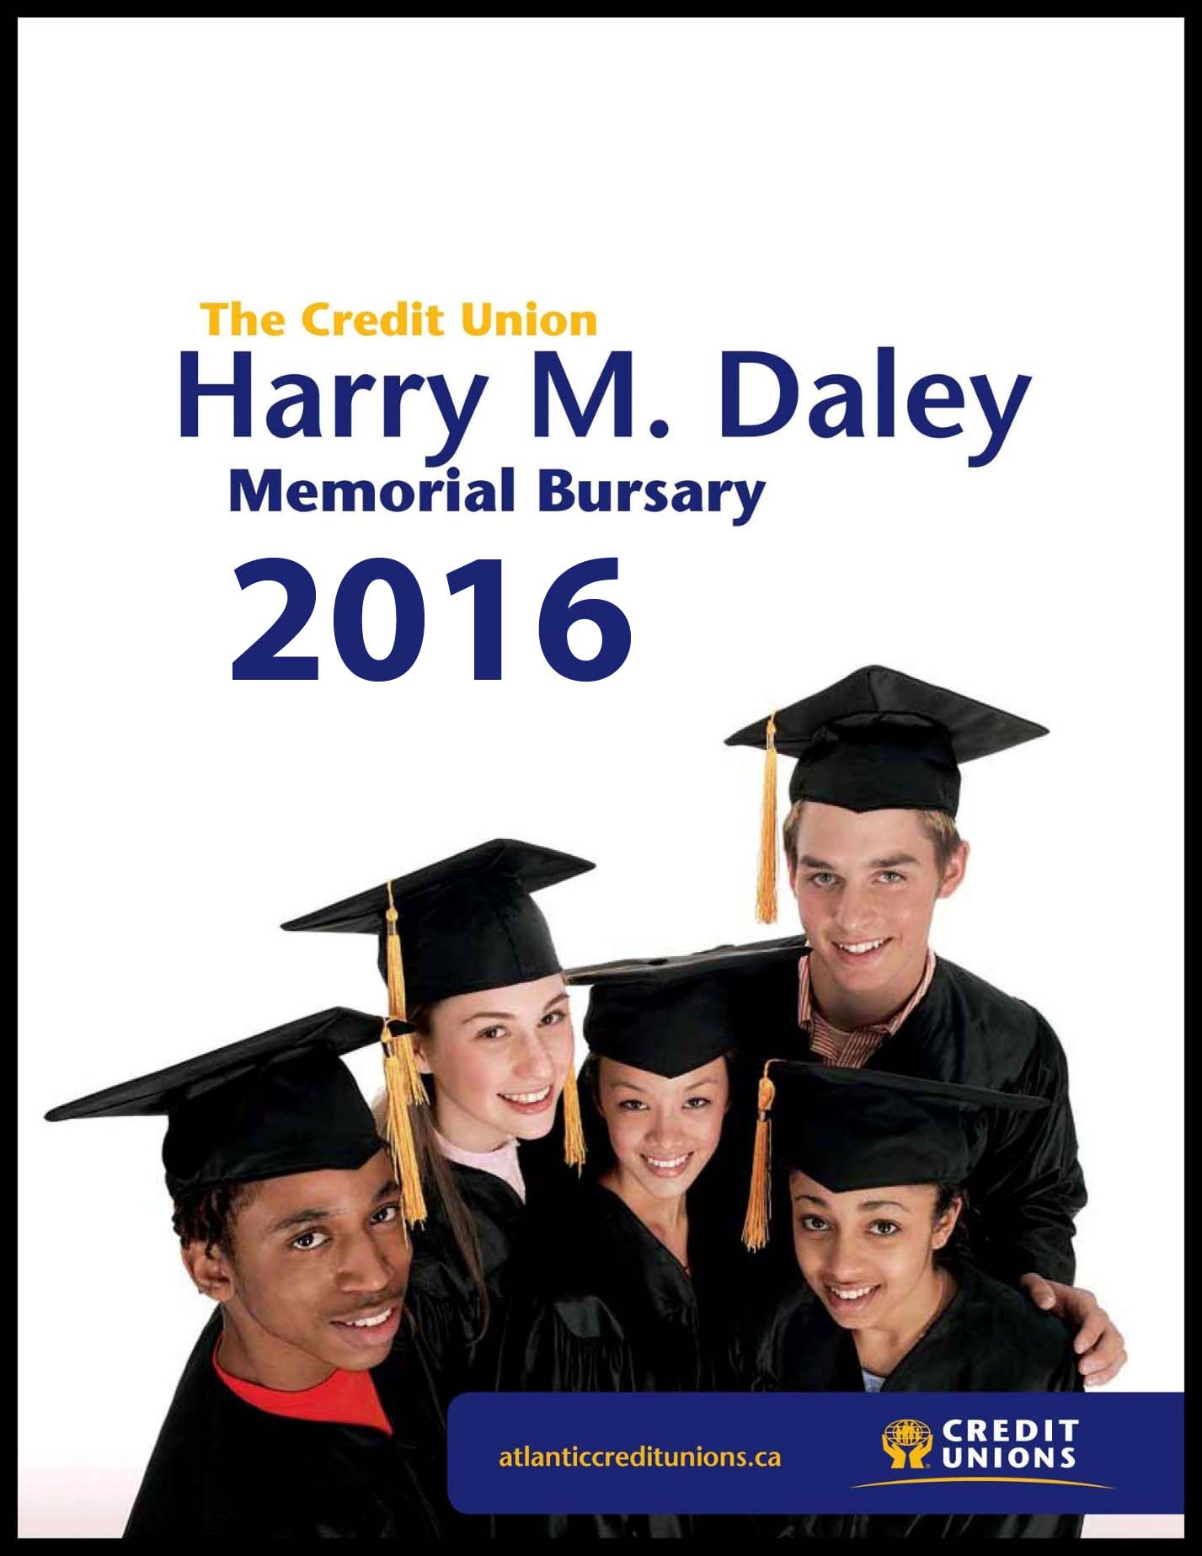

The Credit Union Harry M. Daley Memorial Bursary
2016

The Credit Union Harry M. Daley Memorial Bursary was established in recognition of one of the founding fathers of the Credit Union movement in New Brunswick.
Eight (8) bursaries valued at $3000 each will be awarded in 2016.

Bursary Eligibility

- Open to students pursuing their first year of post-secondary education at an accredited university or college in Canada.
- Students must have lived in NB for at least one (1) year as of the application deadline.
- Two (2) bursaries will be granted to each zone: 1 member/1 non-member for a total of eight.
Zones Counties
Valley Victoria, Carleton, York, Sunbury and Queens
Fundy Charlotte, Saint John and Kings
Hub Albert, Westmorland and Kent
North Northumberland, Gloucester, Restigouche and Madawaska

Submitting Applications:

By Mail:
Trustees of The Credit Union Harry M. Daley Memorial Bursary
c/o NBTA Credit Union
650 Montgomery Street PO Box 752
Fredericton, NB E3B 5R6
Fax: (506) 452-1732

By Email:
Scanned, signed copies of the application can be sent via email to trussell@nbtacu.nb.ca

Deadline For Receipt of Applications is 4:00 pm,
April 29, 2016

The Credit Union Harry M. Daley Memorial Bursary

2016

Student Application Form
(Please type or print clearly)

1. Name of Applicant: _______________________________________________
First Middle Last

2. Date of Birth: __________________
Day/Month/Year

3. Telephone Number: ____________________

Mailing Address: E-mail Address:

_______________________ _______________________

_______________________ Zone: (See page 1)

_______________________ _______________________

4. Do you or your parents belong to a Credit Union? ______________

5. Name of the Credit Union to which you/your parents belong: _______________

6. Name of Credit Union member-owner: _________________________________

7. How long have you been a resident of New Brunswick? ______________

8. Your parents/guardians name, address and telephone number:

______________________________________________________________________
Name Address Telephone #

______________________________________________________________________
Name Address Telephone #

9. Name of your current school: _________________________________
Principal of your current school: ______________________
Telephone # : _______________

10. List all school, extra-curricular, volunteer and community activities in which you have taken part: (use a separate page if necessary)
__________________________________________________________________________________________________________________________________________________________________________________________________________________
______________________________________________________________________
______________________________________________________________________
______________________________________________________________________

11. Do you have a part-time job? _________ If so please describe: ____________________________________________________________________________________________________________________________________________

12. University or college you plan to attend:________________________________

13. Course you plan to follow: ___________________________________________
(A copy of your acceptance letter must accompany this application. Please black out your student ID and Password information if applicable.)

14. Describe your career objective: (use a separate page if necessary)
__________________________________________________________________________________________________________________________________________________________________________________________________________________

15. Please tell us what makes you the best candidate for the Credit Union Harry M. Daley Memorial Bursary: (use a separate page if necessary)

____________________________________________________________________________________________________________________________________________
______________________________________________________________________

16. In 200 words or less, tell us what you feel differentiates Credit Unions from other Financial Institutions. (Please type or print this on a separate page and attach it to the end of your application.)

17. Please indicate any other information which you feel the Trustees should consider when reviewing your application: (use a separate page if necessary)

________________________________________________________________________________________________________________________________________________________________________________________________________________________________________________________________________________________

18. Estimated budget for coming academic year (income and expenses): Yearly Totals

Funding Sources Expenses
Savings ______________ Tuition ______________

Family
Contributions ______________ Books/Supplies ______________

Bursaries/
Scholarships ______________ Room & Board ______________

Other Funds
(RESP, etc.) ______________ Transportation ______________
(Please Specify)
Other ______________

Total _______________ Total _______________

19. Will you be living: _______ at home ______ in residence
_______ boarding ______ in an apartment

20. Please list any bursaries or scholarships you have been awarded:

____________________________________________ ________________
Name of scholarship/bursary Amount

____________________________________________ ________________
Name of scholarship/bursary Amount

____________________________________________ ________________
Name of scholarship/bursary Amount

________________
TOTAL Amount

21. References:
Please attach 2 letters of reference to this application. You may include teachers, clergy, employers, Credit Union managers or other professionals. You may NOT include family members or classmates.

22. Transcript:
Please attach an official, signed transcript of your Grade 11 & 12 marks (to date).

Note:
Before mailing please ensure your application is accompanied by:
___ A copy of your post-secondary institution acceptance letter – See Item #13 on Application Form.
PLEASE BLACKOUT YOUR STUDENT ID AND PASSWORD.
___ An official, SIGNED transcript of your high school marks to date – See Item #22 on Application Form.
___ Confidential family information form (Page 6)
___ 200 Word Essay (Question 16)
___ 2 Signed Letters of Reference – See Item #21 on Application Form

PLEASE NOTE THAT THESE DOCUMENTS MUST EITHER ACCOMPANY THIS APPLICATION OR BE RECEIVED BY THE NBTA CREDIT UNION ON OR BEFORE THE DEADLINE.

Only complete applications forms will be considered for the bursary award.
Additional forms can be downloaded from our website at www.nbtacu.nb.ca

___________________________________ ________________
Applicant's Signature Date

Deadline For Receipt of Applications is 4:00 pm,
April 29, 2016

CONFIDENTIAL
Family information

2016

This page containing family information will be kept in strict confidence by the Trustees. It will be destroyed once the Trustees have made their selection.

1. Name of Applicant :____________________________________________
(Student's Name)

2. Annual family income for 2015:
Employment/business income (gross) __________
Pensions __________
Allowances __________
Other (Specify) __________
Total family income __________

3. Number of persons in household: __________
Parents __________
Children __________
Other (Specify) __________

4. How many contribute to the family income? __________

5. How many are supported by this income? __________

6. Please explain any special family circumstances i.e. support for children who do not live in your home, up-coming retirements, income changes etc.
______________________________________________________________________
________________________________________________________________________________________________________________________________________________________________________________________________________________________________________________________________________________________

____________________________ _____________
Signature of Parent/Guardian Date

Deadline For Receipt of Applications is 4:00 pm,
April 29, 2016

